# DREAM DESTINY(TRAVEL)



A

HCI Course Project Report

in partial fulfilment of the degree

**Bachelor of Technology**

in

**Computer Science & Engineering**

**By**

**MADASI SATHWIK 2303A51430**

**KOMINENI VENU 2303A51960**

Under the guidance of

**Bediga Sharan**

**Assistant Professor**

**Submitted to**

**School of Computer Science and Artificial Intelligence**



**DEPARTMENT OF COMPUTER SCIENCE & ENGINEERING**

**CERTIFICATE**

This is to certify that the **Human Computer Interface – Course Project** Report entitled **“DREAM DESTINY(TRAVEL)”** is a record of bonafide work carried out by the students **M.SATHWIK , K.VENU** bearing Hall Ticket No’s **2303A51430,2303A51960** during the academic year 2024-25 in partial fulfillment of the award of the degree of ***Bachelor of Technology*** in **Computer Science & Engineering** by the SR University, Warangal.

S

**Supervisor Head of the Department**

(Mr. Bediga Sharan) (Dr. M. Sheshikala)

Assistant Professor Professor

**ACKNOWLEDGMENT**

We owe an enormous debt of gratitude to our project guide **Mr. Bediga Sharan**, **Assistant Professor** as well as **Head of the CSE Department (HOD) Dr. M. Sheshikala**, **Professor** for guiding us from the beginning through the end of the Project with their intellectual advices and insightful suggestions. We truly value their consistent feedback on our progress, which was always constructive and encouraging and ultimately drove us to the right direction. We wish to take this opportunity to express our sincere gratitude and deep sense of respect to our beloved **Vice Chancellor, Prof. Deepak Garg**, for his continuous support and guidance to complete this project in the institute. Finally, we express our thanks to all the teaching and non-teaching staff of the department for their suggestions and timely support.

**TABLE OF CONTENT**

|  |  |
| --- | --- |
| **TOPIC** | **PAGE NO** |
| Abstract | 5 |
| Objective | 6 |
| Software and Hardware requirements | 7 |
| Elements Used | 8 |
| Design | 9-11 |
| Implementation | 12-64 |
| Result Screens | 65-67 |
| Conclusion | 68 |

**ABSTRACT**

The Dream Destiny Travel Page is an all-inclusive portal made to make vacation planning easier for

friends and family while guaranteeing affordable, unforgettable travel experiences. With carefully

planned itineraries, reasonably priced lodging, transportation offers, and destination-specific activities,

this creative website links consumers with inexpensive vacation possibilities. Users can tailor trips

according to their choices, including location, budget, and party size, by including sophisticated

search options.

The website also offers suggestions for nearby restaurants, sights, and cultural events, resulting in a

comprehensive itinerary catered to each user's requirements. Travellers may enjoy seamless planning

while optimising their budget with Dream Destiny's user-friendly features, such as expenditure

calculators and real-time updates. By making travel affordable, easy, and stress-free for everyone, this

project hopes to create enduring memories and deep connections, turning aspirations into reality.

**OBJECTIVE**

The Dream Destiny Travel Page's goal is to provide an easy-to-use, all-inclusive

platform that enables friends and family to organise amazing vacations without breaking the bank.

Our goal is to make everyone's travel fantasies a reality by providing specialised, reasonably priced,

and experience-rich travel options.

Users can browse a range of affordable vacation packages, special offers, and

personalised itineraries made to fit various spending limits and tastes via this page. By offering all

required services, including reservations for lodging, modes of transportation, plans for sightseeing,

and carefully chosen suggestions for meals and activities, we hope to make the process of organising a

trip easier.

The Dream Destiny Travel Page guarantees that consumers may concentrate on making

priceless experiences with their loved ones by promoting transparency, affordability, and ease. We

also offer advice, guides, and round-the-clock assistance to make travel joyful and stress-free. Our

objective is to establish ourselves as a reliable travel companion for tourists looking to experience the

world while remaining within their means, eventually making their ideal getaways a reality.

**SOFTWARE AND HARDWARE REQUIREMENTS**

**SOFTWARE REQUIREMENTS:**

**TECHNICAL REQUIREMENTS:**

**>** HTML

**>** CSS

**>** JAVASCRIPT

**HARDWARE REQUIREMENTS:**

**Server:**

You'll need a robust server to host the travel management system's database and application. The server should have sufficient processing power, memory, and storage capacity to handle the expected workload, ensuring smooth functionality and seamless user experiences for trip planning and bookings.

**Database Server:**

A database server is essential to store and manage data related to travel packages, bookings, user information, and payment details. It should have adequate storage and memory to ensure efficient data handling and quick access to information.

**Network Infrastructure:**

Reliable networking equipment, including routers, switches, and a high-speed internet connection, is crucial to ensure smooth communication between various components of the travel management system. This ensures seamless access for users and uninterrupted functionality of the platform.

**ELEMENTS USED**

**1. Home**The homepage serves as the gateway to your dream trips. It offers a welcoming introduction, showcasing the best travel packages, top destinations, and special offers. Designed for simplicity and navigation ease, this page inspires families and friends to explore affordable travel options.

**2. Book**This section allows users to plan and book trips effortlessly. With customizable options like choosing destinations, dates, and budget preferences, it ensures a hassle-free experience for every traveler.

**3. Packages**Discover diverse, budget-friendly packages tailored to meet various preferences. Whether it’s a beach getaway, adventure trip, or serene countryside retreat, this page provides a detailed breakdown of cost, itinerary, and inclusions.

**4. Services**From transportation to accommodation, meals, and local guides, this section highlights the comprehensive services offered. Families and friends can trust us for a seamless travel experience.

**5. Gallery**A collection of captivating photos and videos from previous trips to inspire wanderlust. This section builds trust by showing happy customers enjoying their dream destinations.

**6. About Us**Learn about Dream Destiny Travel’s mission to make budget-friendly trips a reality. With our commitment to quality and affordability, this section reinforces our values and dedication to customer satisfaction.

**DESIGN**

SCREEN-1:

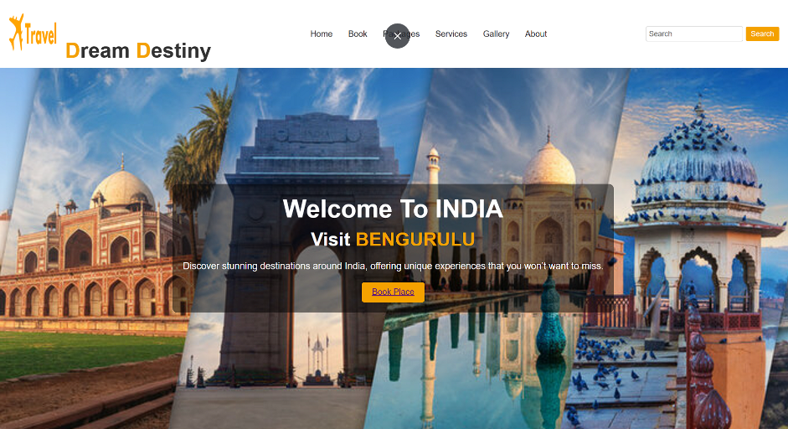

SCREEN-2:

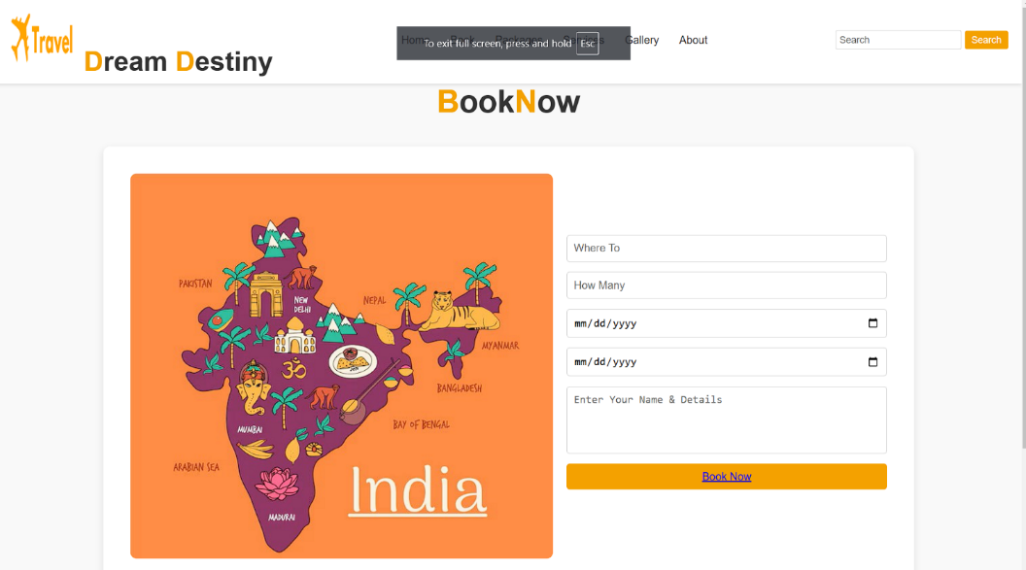

SCREEN-3:

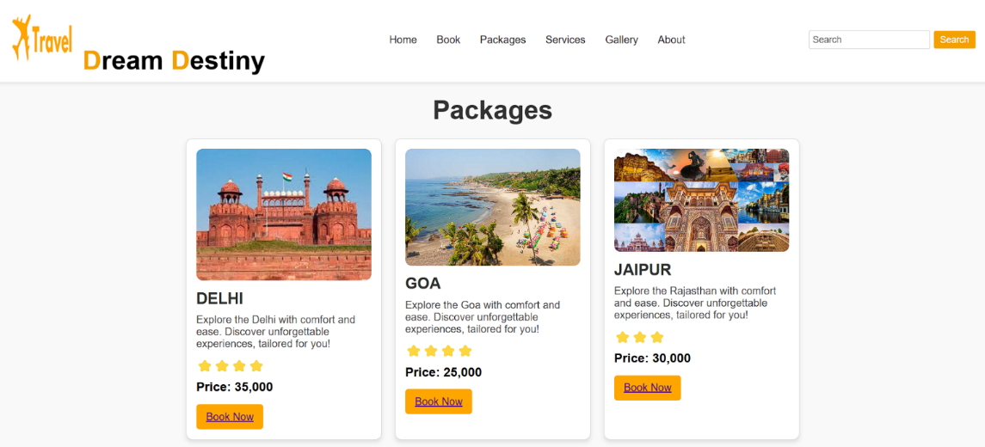

SCREEN-4:

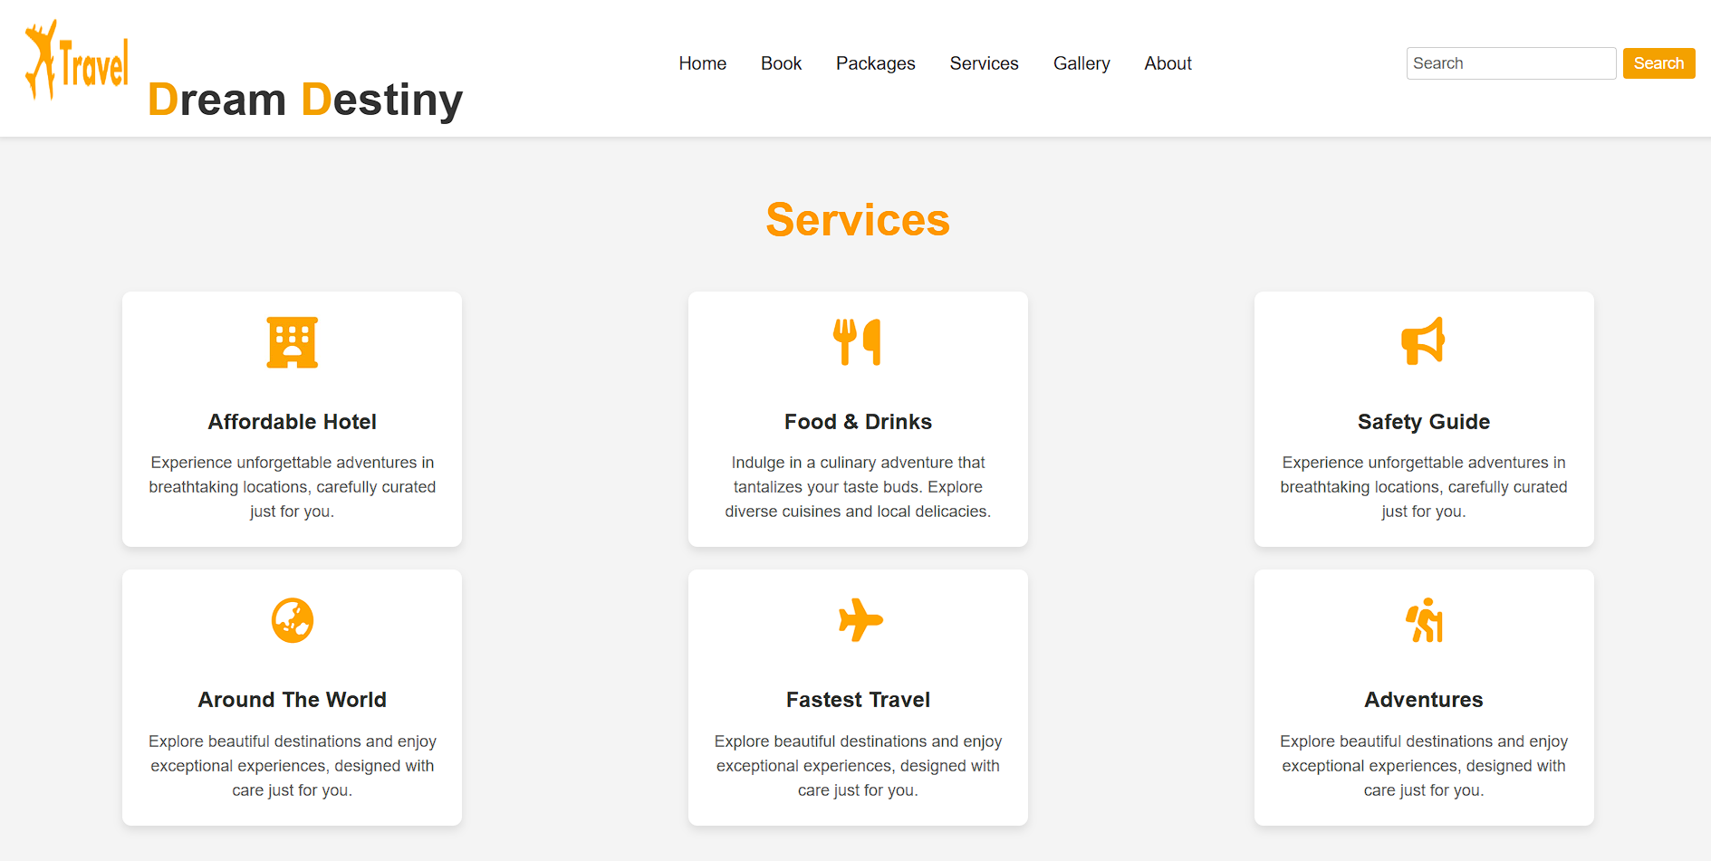

SCREEN-5:

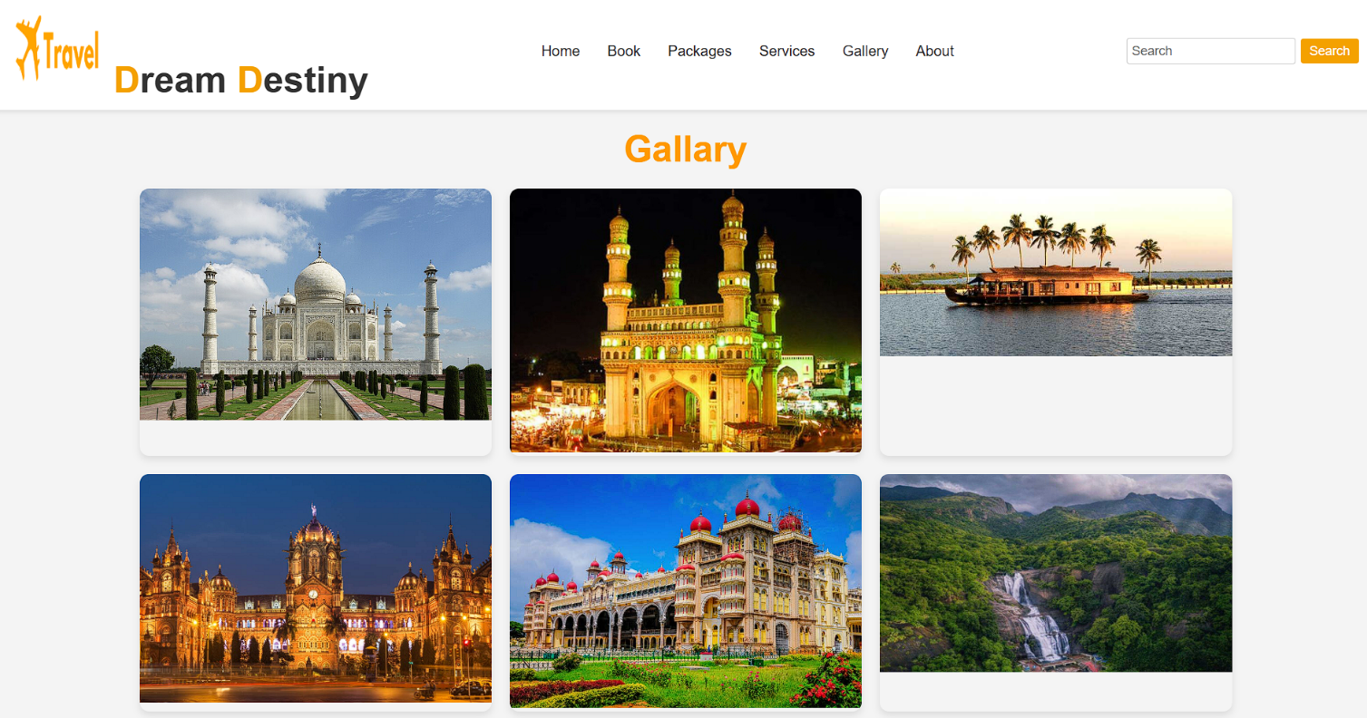

SCREEN-6:

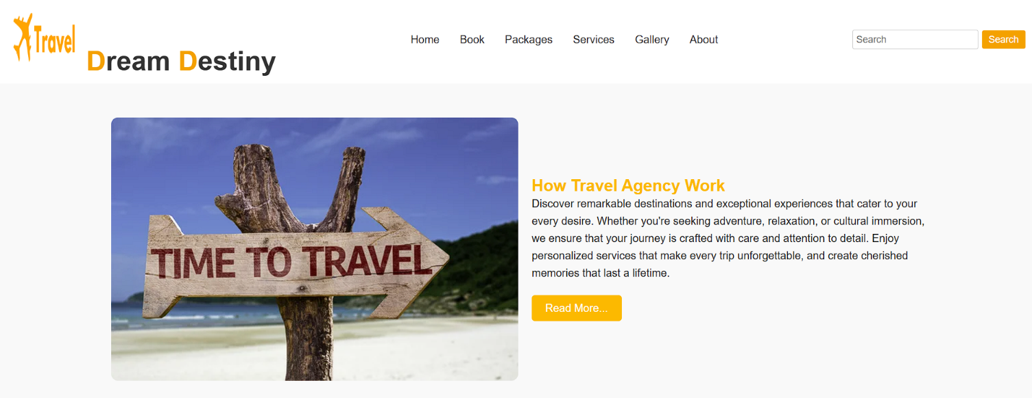

**IMPLEMENTATION**

CODE:

Home.html

<!DOCTYPE html>

<html lang="en">

<head>

    <title>Travel Dream Destiny</title>

    <link href="https://cdnjs.cloudflare.com/ajax/libs/font-awesome/6.5.0/css/all.min.css" rel="stylesheet">

    <style>

* {

    margin: 0;

    padding: 0;

    box-sizing: border-box;

}

body {

    font-family: Arial, sans-serif;

    background-color: #f4f4f4;

    color: #333;

}

header {

    display: flex;

    justify-content: space-between;

    align-items: center;

    padding: 10px 20px;

    background: white;

    box-shadow: 0 2px 5px rgba(0, 0, 0, 0.1);

}

header .logo {

    font-size: 40px;

    font-weight: bold;

}

header .logo .orange {

    color: #f4a100;

}

header nav ul {

    list-style: none;

    display: flex;

}

header nav ul li {

    margin: 0 15px;

}

header nav ul li a {

    text-decoration: none;

    color: #333;

    font-size: 16px;

}

header nav ul li a:hover{

    background: #ffa500;

    color: white;

    padding: 5px 10px;

    border-radius: 3px;

}

header .search-bar {

    display: flex;

    align-items: center;

}

header .search-bar input {

    padding: 5px;

    font-size: 14px;

    border: 1px solid #ccc;

    border-radius: 3px;

    margin-right: 5px;

}

header .search-bar button {

    padding: 5px 10px;

    font-size: 14px;

    border: none;

    background-color: #f4a100;

    color: white;

    border-radius: 3px;

    cursor: pointer;

}

.hero {

    position: relative;

    background: url('https://t4.ftcdn.net/jpg/05/05/51/25/360_F_505512599_D6ulJI9hV6aGTP04FPC2XDk5QHGOQtpW.jpg') no-repeat center center/cover;

    height: 80vh;

    color: white;

    text-align: center;

    display: flex;

    align-items: center;

    justify-content: center;

}

.hero .overlay {

    background-color: rgba(0, 0, 0, 0.5);

    padding: 20px;

    border-radius: 10px;

}

.hero h1 {

    font-size: 48px;

    margin-bottom: 10px;

}

.hero h2 {

    font-size: 36px;

    margin-bottom: 20px;

}

.hero h2 span {

    color: #f4a100;

}

.hero p {

    font-size: 18px;

    margin-bottom: 20px;

}

.hero button {

    padding: 10px 20px;

    font-size: 16px;

    background-color: #f4a100;

    color: white;

    border: none;

    border-radius: 5px;

    cursor: pointer;

}

footer {

    background-color: #fff;

    padding: 20px;

    text-align: center;

}

.footer-content {

    max-width: 800px;

    margin: 0 auto;

}

.footer-content h2 {

    color: #fcb900;

}

.footer-content p {

    color: #666;

    line-height: 1.6;

}

.social-icons {

    margin-top: 20px;

}

.social-icons a {

    display: inline-block;

    margin: 0 10px;

}

.social-icons img {

    width: 24px;

    height: 24px;

}

    </style>

</head>

<body>

    <header>

        <div class="logo">

              <img src="logo.png" alt="travel logo" width="100" height="100">

            <span class="orange">D</span>ream <span class="orange">D</span><span class="none">estiny</span>

        </div>

        <nav>

            <ul>

                <li><a href="home.html">Home</a></li>

                <li><a href="book.html">Book</a></li>

                <li><a href="packages.html">Packages</a></li>

                <li><a href="services.html">Services</a></li>

                <li><a href="gallery.html">Gallery</a></li>

                <li><a href="aboutus.html">About</a></li>

            </ul>

        </nav>

        <div class="search-bar">

            <input type="text" placeholder="Search">

            <button>Search</button>

        </div>

    </header>

    <main>

        <section class="hero">

            <div class="overlay">

                <h1>Welcome To INDIA</h1>

                <h2>Visit <span id="place-name">INDIAN PLACES</span></h2>

                <p>Discover stunning destinations around India, offering unique experiences that you won’t want to miss.</p>

                <button><a href="packages.html">Book Place</a></button>

            </div>

        </section>

    </main>

    <script>

        const placeNames = ['DELHI', 'MUMBAI', 'BENGURULU', 'HYDERABAD', 'CHENNAI'];

        let currentIndex = 0;

        setInterval(() => {

            document.getElementById('place-name').innerText = placeNames[currentIndex];

            currentIndex = (currentIndex + 1) % placeNames.length;

        }, 1000);

    </script>

   <footer>

        <div class="footer-content">

            <h2>DreamDestiny</h2>

            <p>Explore stunning destinations that offer unique experiences tailored to your interests. Discover breathtaking landscapes, vibrant cultures, and adventures that create lasting memories.</p>

            <div class="social-icons">

            <a href="https://facebook.com" target="_blank" class="social-icon"><i class="fab fa-facebook-f"></i></a>

            <a href="https://twitter.com" target="_blank" class="social-icon"><i class="fab fa-twitter"></i></a>

            <a href="https://instagram.com" target="_blank" class="social-icon"><i class="fab fa-instagram"></i></a>

            <a href="https://youtube.com" target="_blank" class="social-icon"><i class="fab fa-youtube"></i></a>

            <a href="https://pinterest.com" target="_blank" class="social-icon"><i class="fab fa-pinterest"></i></a>

        </div>

        <p class="footer-text">

                Designed by <strong>MADASISATHWIK</strong> | &copy; CopyrightsMadasiSathwik All Rights Reserved

            </p>

        </div>

    </footer>

</body>

</html>

CODE-2:

<!DOCTYPE html>

<html lang="en">

<head>

    <title>Book Journey</title>

<link href="https://cdnjs.cloudflare.com/ajax/libs/font-awesome/6.5.0/css/all.min.css" rel="stylesheet">

<style>

* {

    margin: 0;

    padding: 0;

    box-sizing: border-box;

}

body {

    font-family: Arial, sans-serif;

    background-color: #f9f9f9;

    color: #333;

}

header {

    display: flex;

    justify-content: space-between;

    align-items: center;

    padding: 10px 20px;

    background: white;

    box-shadow: 0 2px 5px rgba(0, 0, 0, 0.1);

}

header .logo {

    font-size: 40px;

    font-weight: bold;

}

header .logo .orange {

    color: #f4a100;

}

header nav ul {

    list-style: none;

    display: flex;

}

header nav ul li {

    margin: 0 15px;

}

header nav ul li a {

    text-decoration: none;

    color: #333;

    font-size: 16px;

}

header .search-bar {

    display: flex;

    align-items: center;

}

header .search-bar input {

    padding: 5px;

    font-size: 14px;

    border: 1px solid #ccc;

    border-radius: 3px;

    margin-right: 5px;

}

header .search-bar button {

    padding: 5px 10px;

    font-size: 14px;

    border: none;

    background-color: #f4a100;

    color: white;

    border-radius: 3px;

    cursor: pointer;

}

 h1 {

    font-size: 46px;

    text-align: center;

}

.highlight {

    color: #f4a100;

}

.booking-container {

    display: flex;

    justify-content: space-between;

    align-items: center;

    padding: 40px;

    max-width: 1200px;

    margin: 40px auto;

    background: white;

    box-shadow: 0 4px 10px rgba(0, 0, 0, 0.1);

    border-radius: 10px;

}

.image-section img {

    max-width: 100%;

    border-radius: 10px;

}

.form-section {

    flex: 1;

    margin-left: 20px;

}

.form-section form {

    display: flex;

    flex-direction: column;

}

.form-section input,

.form-section textarea,

.form-section button {

    margin-bottom: 15px;

    padding: 10px;

    font-size: 16px;

    border: 1px solid #ccc;

    border-radius: 5px;

    outline: none;

}

.form-section textarea {

    height: 100px;

    resize: none;

}

.form-section button {

    background-color: #f4a100;

    color: white;

    border: none;

    cursor: pointer;

    transition: background-color 0.3s;

}

.form-section button:hover {

    background-color: #d38700;

}

footer {

    background-color: #fff;

    padding: 20px;

    text-align: center;

}

.footer-content {

    max-width: 800px;

    margin: 0 auto;

}

.footer-content h2 {

    color: #fcb900;

}

.footer-content p {

    color: #666;

    line-height: 1.6;

}

.social-icons {

    margin-top: 20px;

}

.social-icons a {

    display: inline-block;

    margin: 0 10px;

}

.social-icons img {

    width: 24px;

    height: 24px;

}

    </style>

</head>

<body>

   <header>

        <div class="logo">

              <img src="logo.png" alt="travel logo" width="100" height="100">

            <span class="orange">D</span>ream <span class="orange">D</span><span class="none">estiny</span>

        </div>

        <nav>

            <ul>

                <li><a href="home.html">Home</a></li>

                <li><a href="book.html">Book</a></li>

                <li><a href="packages.html">Packages</a></li>

                <li><a href="services.html">Services</a></li>

                <li><a href="gallery.html">Gallery</a></li>

                <li><a href="aboutus.html">About</a></li>

            </ul>

        </nav>

        <div class="search-bar">

            <input type="text" placeholder="Search">

            <button>Search</button>

        </div>

    </header>

    <main>

    <h1><span class="highlight">B</span>ook<span class="highlight">N</span>ow</h1>

        <div class="booking-container">

            <div class="image-section">

                <img src="book.jpg" alt="World Destinations">

            </div>

            <div class="form-section">

                <form action="confirmation.html" method="POST">

                    <input type="text" name="destination" placeholder="Where To" required>

                    <input type="number" name="people" placeholder="How Many" required>

                    <input type="date" name="start-date" placeholder="dd-mm-yyyy" required>

                    <input type="date" name="end-date" placeholder="dd-mm-yyyy" required>

                    <textarea name="details" placeholder="Enter Your Name & Details" required></textarea>

                    <button type="submit"><a href="confirmation.html">Book Now<a></button>

                </form>

            </div>

        </div>

    </main>

<footer>

        <div class="footer-content">

            <h2>DreamDestiny</h2>

            <p>Explore stunning destinations that offer unique experiences tailored to your interests. Discover breathtaking landscapes, vibrant cultures, and adventures that create lasting memories.</p>

            <div class="social-icons">

            <a href="https://facebook.com" target="_blank" class="social-icon"><i class="fab fa-facebook-f"></i></a>

            <a href="https://twitter.com" target="_blank" class="social-icon"><i class="fab fa-twitter"></i></a>

            <a href="https://instagram.com" target="_blank" class="social-icon"><i class="fab fa-instagram"></i></a>

            <a href="https://youtube.com" target="_blank" class="social-icon"><i class="fab fa-youtube"></i></a>

            <a href="https://pinterest.com" target="_blank" class="social-icon"><i class="fab fa-pinterest"></i></a>

        </div>

        <p class="footer-text">

                Designed by <strong>MADASISATHWIK</strong> | &copy; CopyrightsMadasiSathwik All Rights Reserved

            </p>

        </div>

    </footer>

</body>

</html>

CODE-3:

<!DOCTYPE html>

<html lang="en">

<head>

    <title>Confirmation</title>

<link href="https://cdnjs.cloudflare.com/ajax/libs/font-awesome/6.5.0/css/all.min.css" rel="stylesheet">

    <style>

        body {

            font-family: Arial, sans-serif;

            background-color: #f9f9f9;

            text-align: center;

            color: #333;

            margin-top: 50px;

        }

        .confirmation {

            padding: 20px;

            background: #fff;

            margin: auto;

            width: 50%;

            box-shadow: 0 4px 10px rgba(0, 0, 0, 0.1);

            border-radius: 10px;

        }

        .confirmation h1 {

            color: #f4a100;

        }

        .confirmation p {

            font-size: 18px;

        }

        .confirmation a {

            display: inline-block;

            margin-top: 20px;

            padding: 10px 20px;

            text-decoration: none;

            background-color: #f4a100;

            color: white;

            border-radius: 5px;

            transition: background-color 0.3s;

        }

        .confirmation a:hover {

            background-color: #d38700;

        }

footer {

    background-color: #fff;

    padding: 20px;

    text-align: center;

}

.footer-content {

    max-width: 800px;

    margin: 0 auto;

}

.footer-content h2 {

    color: #fcb900;

}

.footer-content p {

    color: #666;

    line-height: 1.6;

}

.social-icons {

    margin-top: 20px;

}

.social-icons a {

    display: inline-block;

    margin: 0 10px;

}

.social-icons img {

    width: 24px;

    height: 24px;

}

    </style>

</head>

<body>

    <div class="confirmation">

        <h1>Journey Booked!</h1>

        <p>Thank you for booking your trip. We look forward to serving you on your adventure!</p>

        <a href="home.html">Back to Home</a>

    </div>

<footer>

        <div class="footer-content">

            <h2>DreamDestiny</h2>

            <p>Explore stunning destinations that offer unique experiences tailored to your interests. Discover breathtaking landscapes, vibrant cultures, and adventures that create lasting memories.</p>

            <div class="social-icons">

            <a href="https://facebook.com" target="_blank" class="social-icon"><i class="fab fa-facebook-f"></i></a>

            <a href="https://twitter.com" target="_blank" class="social-icon"><i class="fab fa-twitter"></i></a>

            <a href="https://instagram.com" target="_blank" class="social-icon"><i class="fab fa-instagram"></i></a>

            <a href="https://youtube.com" target="_blank" class="social-icon"><i class="fab fa-youtube"></i></a>

            <a href="https://pinterest.com" target="_blank" class="social-icon"><i class="fab fa-pinterest"></i></a>

        </div>

        <p class="footer-text">

                Designed by <strong>MADASISATHWIK</strong> | &copy; CopyrightsMadasiSathwik All Rights Reserved

            </p>

        </div>

    </footer>

</body>

</html>

CODE-4:

<!DOCTYPE html>

<html lang="en">

<head>

  <title>Travel Packages</title>

<link href="https://cdnjs.cloudflare.com/ajax/libs/font-awesome/6.5.0/css/all.min.css" rel="stylesheet">

<style>

* {

    margin: 0;

    padding: 0;

    box-sizing: border-box;

}

body {

  font-family: Arial, sans-serif;

  margin: 0;

  padding: 0;

  background-color: #f9f9f9;

}

header {

    display: flex;

    justify-content: space-between;

    align-items: center;

    padding: 10px 20px;

    background: white;

    box-shadow: 0 2px 5px rgba(0, 0, 0, 0.1);

}

header .logo {

    font-size: 40px;

    font-weight: bold;

}

header .logo .orange {

    color: #f4a100;

}

header nav ul {

    list-style: none;

    display: flex;

}

header nav ul li {

    margin: 0 15px;

}

header nav ul li a {

    text-decoration: none;

    color: #333;

    font-size: 16px;

}

header nav ul li a:hover{

    background: #ffa500;

    color: white;

    padding: 5px 10px;

    border-radius: 3px;

}

header .search-bar {

    display: flex;

    align-items: center;

}

header .search-bar input {

    padding: 5px;

    font-size: 14px;

    border: 1px solid #ccc;

    border-radius: 3px;

    margin-right: 5px;

}

header .search-bar button {

    padding: 5px 10px;

    font-size: 14px;

    border: none;

    background-color: #f4a100;

    color: white;

    border-radius: 3px;

    cursor: pointer;

}

.container {

  max-width: 1200px;

  margin: 0 auto;

  padding: 20px;

  text-align: center;

}

.title {

  font-size: 2.5em;

  margin-bottom: 20px;

  color: #333;

}

.packages {

  display: flex;

  flex-wrap: wrap;

  justify-content: center;

  gap: 20px;

}

.package-card {

  background: #fff;

  border: 1px solid #ddd;

  border-radius: 10px;

  width: 300px;

  padding: 15px;

  box-shadow: 0 4px 6px rgba(0, 0, 0, 0.1);

  text-align: left;

}

.package-card img {

  width: 100%;

  border-radius: 10px;

}

.package-card h2 {

  font-size: 1.5em;

  color: #333;

  margin: 10px 0;

}

.package-card p {

  font-size: 1em;

  color: #555;

  margin: 10px 0;

}

.rating {

  font-size: 1.2em;

  color: #ffa500;

  margin: 10px 0;

}

.price {

  font-size: 1.2em;

  font-weight: bold;

  color: #000;

  margin-bottom: 15px;

}

button {

  background-color: #ffa500;

  color: #fff;

  border: none;

  padding: 10px 15px;

  border-radius: 5px;

  font-size: 1em;

  cursor: pointer;

}

button:hover {

  background-color: #ff7b00;

}

footer {

    background-color: #fff;

    padding: 20px;

    text-align: center;

}

.footer-content {

    max-width: 800px;

    margin: 0 auto;

}

.footer-content h2 {

    color: #fcb900;

}

.footer-content p {

    color: #666;

    line-height: 1.6;

}

.social-icons {

    margin-top: 20px;

}

.social-icons a {

    display: inline-block;

    margin: 0 10px;

}

.social-icons img {

    width: 24px;

    height: 24px;

}

</style>

</head>

<body>

<header>

        <div class="logo">

              <img src="logo.png" alt="travel logo" width="100" height="100">

            <span class="orange">D</span>ream <span class="orange">D</span><span class="none">estiny</span>

        </div>

        <nav>

            <ul>

               <li><a href="home.html">Home</a></li>

                <li><a href="book.html">Book</a></li>

                <li><a href="packages.html">Packages</a></li>

                <li><a href="services.html">Services</a></li>

                <li><a href="gallery.html">Gallery</a></li>

                <li><a href="aboutus.html">About</a></li>

            </ul>

        </nav>

        <div class="search-bar">

            <input type="text" placeholder="Search">

            <button>Search</button>

        </div>

    </header>

<main>

  <div class="container">

    <h1 class="title">Packages</h1>

    <div class="packages">

      <div class="package-card">

        <img src="https://encrypted-tbn0.gstatic.com/images?q=tbn:ANd9GcSC095mZ7NIvlYwo3mSTY8MSKGit9_dv4FTbw&s" alt="delhi">

        <h2>DELHI</h2>

        <p>Explore the Delhi with comfort and ease. Discover unforgettable experiences, tailored for you!</p>

        <div class="rating">⭐⭐⭐⭐</div>

        <div class="price">Price: 35,000</div>

        <button><a href="book.html">Book Now</a></button>

      </div>

      <div class="package-card">

        <img src="https://www.holidify.com/images/bgImages/GOA.jpg" alt="goa">

        <h2>GOA</h2>

        <p>Explore the Goa with comfort and ease. Discover unforgettable experiences, tailored for you!</p>

        <div class="rating">⭐⭐⭐⭐</div>

        <div class="price">Price: 25,000</div>

        <button><a href="book.html">Book Now</a></button>

      </div>

      <div class="package-card">

        <img src="https://www.rajasthanbhumitours.com/blog/wp-content/uploads/2024/08/Places-To-Visit-In-Rajasthan-With-Family.jpg" alt="jaipur">

        <h2>JAIPUR</h2>

        <p>Explore the Rajasthan with comfort and ease. Discover unforgettable experiences, tailored for you!</p>

        <div class="rating">⭐⭐⭐</div>

        <div class="price">Price: 30,000</div>

        <button><a href="book.html">Book Now</a></button>

      </div>

      <div class="package-card">

        <img src="https://www.holidify.com/images/bgImages/HYDERABAD.jpg" alt="hyderabad">

        <h2>HYDERABAD</h2>

        <p>Explore the Hyderabad with comfort and ease. Discover unforgettable experiences, tailored for you!</p>

        <div class="rating">⭐⭐⭐⭐</div>

        <div class="price">Price: 20,000</div>

        <button><a href="book.html">Book Now</a></button>

      </div>

      <div class="package-card">

        <img src="https://media.easemytrip.com/media/Blog/India/637033873695687971/637033873695687971exGTcR.jpg" alt="kerala">

        <h2>KERALA</h2>

        <p>Explore the Kerala with comfort and ease. Discover unforgettable experiences, tailored for you!</p>

        <div class="rating">⭐⭐⭐⭐⭐</div>

        <div class="price">Price: 15,000</div>

        <button><a href="book.html">Book Now</a></button>

      </div>

      <div class="package-card">

        <img src="https://ihplb.b-cdn.net/wp-content/uploads/2017/03/Brihadeeswarar-TempleThanjavur.jpg" alt="tamil">

        <h2>TAMILNADU</h2>

        <p>Explore the Tamilnadu with comfort and ease. Discover unforgettable experiences, tailored for you!</p>

        <div class="rating">⭐⭐⭐⭐⭐</div>

        <div class="price">Price: 15,000</div>

        <button><a href="book.html">Book Now</a></button>

      </div>

    </div>

  </div>

<main>

<footer>

        <div class="footer-content">

            <h2>DreamDestiny</h2>

            <p>Explore stunning destinations that offer unique experiences tailored to your interests. Discover breathtaking landscapes, vibrant cultures, and adventures that create lasting memories.</p>

            <div class="social-icons">

            <a href="https://facebook.com" target="_blank" class="social-icon"><i class="fab fa-facebook-f"></i></a>

            <a href="https://twitter.com" target="_blank" class="social-icon"><i class="fab fa-twitter"></i></a>

            <a href="https://instagram.com" target="_blank" class="social-icon"><i class="fab fa-instagram"></i></a>

            <a href="https://youtube.com" target="_blank" class="social-icon"><i class="fab fa-youtube"></i></a>

            <a href="https://pinterest.com" target="_blank" class="social-icon"><i class="fab fa-pinterest"></i></a>

        </div>

        <p class="footer-text">

                Designed by <strong>MADASISATHWIK</strong> | &copy; CopyrightsMadasiSathwik All Rights Reserved

            </p>

        </div>

    </footer>

</body>

</html>

CODE-5:

<!DOCTYPE html>

<html lang="en">

<head>

  <title>Services Section</title>

<link href="https://cdnjs.cloudflare.com/ajax/libs/font-awesome/6.5.0/css/all.min.css" rel="stylesheet">

  <style>

* {

    margin: 0;

    padding: 0;

    box-sizing: border-box;

}

body {

    font-family: Arial, sans-serif;

    background-color: #f4f4f4;

    color: #333;

}

header {

    display: flex;

    justify-content: space-between;

    align-items: center;

    padding: 10px 20px;

    background: white;

    box-shadow: 0 2px 5px rgba(0, 0, 0, 0.1);

}

header .logo {

    font-size: 40px;

    font-weight: bold;

}

header .logo .orange {

    color: #f4a100;

}

header nav ul {

    list-style: none;

    display: flex;

}

header nav ul li {

    margin: 0 15px;

}

header nav ul li a {

    text-decoration: none;

    color: #333;

    font-size: 16px;

}

header nav ul li a:hover{

    background: #ffa500;

    color: white;

    padding: 5px 10px;

    border-radius: 3px;

}

header .search-bar {

    display: flex;

    align-items: center;

}

header .search-bar input {

    padding: 5px;

    font-size: 14px;

    border: 1px solid #ccc;

    border-radius: 3px;

    margin-right: 5px;

}

header .search-bar button {

    padding: 5px 10px;

    font-size: 14px;

    border: none;

    background-color: #f4a100;

    color: white;

    border-radius: 3px;

    cursor: pointer;

}

.services {

  text-align: center;

  padding: 50px 20px;

}

.services h1 {

  font-size: 2.5rem;

  color: #ff9900;

  margin-bottom: 40px;

}

.services-container {

  display: grid;

  grid-template-columns: repeat(3, 1fr);

  gap: 20px;

  justify-items: center;

}

.service-card {

  background: #fff;

  border-radius: 8px;

  box-shadow: 0 4px 8px rgba(0, 0, 0, 0.1);

  padding: 20px;

  text-align: center;

  max-width: 300px;

}

.service-card img {

  width: 50px;

  height: 50px;

  margin-bottom: 15px;

}

.service-card h2 {

  font-size: 1.2rem;

  margin: 15px 0;

  color: #333;

}

.service-card p {

  font-size: 0.9rem;

  color: #666;

  line-height: 1.5;

}

footer {

    background-color: #fff;

    padding: 20px;

    text-align: center;

}

.footer-content {

    max-width: 800px;

    margin: 0 auto;

}

.footer-content h2 {

    color: #fcb900;

}

.footer-content p {

    color: #666;

    line-height: 1.6;

}

.social-icons {

    margin-top: 20px;

}

.social-icons a {

    display: inline-block;

    margin: 0 10px;

}

.social-icons img {

    width: 24px;

    height: 24px;

}

  </style>

</head>

<body>

<header>

        <div class="logo">

              <img src="logo.png" alt="travel logo" width="100" height="100">

            <span class="orange">D</span>ream <span class="orange">D</span><span class="none">estiny</span>

        </div>

        <nav>

            <ul>

                <li><a href="home.html">Home</a></li>

                <li><a href="book.html">Book</a></li>

                <li><a href="packages.html">Packages</a></li>

                <li><a href="services.html">Services</a></li>

                <li><a href="gallery.html">Gallery</a></li>

                <li><a href="aboutus.html">About</a></li>

            </ul>

        </nav>

        <div class="search-bar">

            <input type="text" placeholder="Search">

            <button>Search</button>

        </div>

    </header>

  <section class="services">

    <h1><span class="orange">S</span>ervices</h1>

    <div class="services-container">

      <div class="service-card">

        <img src="hotel.jpg" alt="Hotel Icon">

        <h2>Affordable Hotel</h2>

        <p>Experience unforgettable adventures in breathtaking locations, carefully curated just for you.</p>

      </div>

      <div class="service-card">

        <img src="food.png" alt="Food Icon">

        <h2>Food & Drinks</h2>

        <p>Indulge in a culinary adventure that tantalizes your taste buds. Explore diverse cuisines and local delicacies.</p>

      </div>

      <div class="service-card">

        <img src="safty.png" alt="Safety Icon">

        <h2>Safety Guide</h2>

        <p>Experience unforgettable adventures in breathtaking locations, carefully curated just for you.</p>

      </div>

      <div class="service-card">

        <img src="world.png" alt="World Icon">

        <h2>Around The World</h2>

        <p>Explore beautiful destinations and enjoy exceptional experiences, designed with care just for you.</p>

      </div>

      <div class="service-card">

        <img src="travel.png" alt="Plane Icon">

        <h2>Fastest Travel</h2>

        <p>Explore beautiful destinations and enjoy exceptional experiences, designed with care just for you.</p>

      </div>

      <div class="service-card">

        <img src="adventure.png" alt="Adventure Icon">

        <h2>Adventures</h2>

        <p>Explore beautiful destinations and enjoy exceptional experiences, designed with care just for you.</p>

      </div>

    </div>

  </section>

<footer>

        <div class="footer-content">

            <h2>DreamDestiny</h2>

            <p>Explore stunning destinations that offer unique experiences tailored to your interests. Discover breathtaking landscapes, vibrant cultures, and adventures that create lasting memories.</p>

            <div class="social-icons">

            <a href="https://facebook.com" target="_blank" class="social-icon"><i class="fab fa-facebook-f"></i></a>

            <a href="https://twitter.com" target="_blank" class="social-icon"><i class="fab fa-twitter"></i></a>

            <a href="https://instagram.com" target="_blank" class="social-icon"><i class="fab fa-instagram"></i></a>

            <a href="https://youtube.com" target="_blank" class="social-icon"><i class="fab fa-youtube"></i></a>

            <a href="https://pinterest.com" target="_blank" class="social-icon"><i class="fab fa-pinterest"></i></a>

        </div>

        <p class="footer-text">

                Designed by <strong>MADASISATHWIK</strong> | &copy; CopyrightsMadasiSathwik All Rights Reserved

            </p>

        </div>

    </footer>

</body>

</html>

CODE-6:

<!DOCTYPE html>

<html lang="en">

<head>

  <title>Gallery</title>

<link href="https://cdnjs.cloudflare.com/ajax/libs/font-awesome/6.5.0/css/all.min.css" rel="stylesheet">

<style>

* {

    margin: 0;

    padding: 0;

    box-sizing: border-box;

}

body {

  font-family: Arial, sans-serif;

  margin: 0;

  padding: 0;

  background-color: #f9f9f9;

}

body {

    font-family: Arial, sans-serif;

    background-color: #f4f4f4;

    color: #333;

}

header {

    display: flex;

    justify-content: space-between;

    align-items: center;

    padding: 10px 20px;

    background: white;

    box-shadow: 0 2px 5px rgba(0, 0, 0, 0.1);

}

header .logo {

    font-size: 40px;

    font-weight: bold;

}

header .logo .orange {

    color: #f4a100;

}

header nav ul {

    list-style: none;

    display: flex;

}

header nav ul li {

    margin: 0 15px;

}

header nav ul li a {

    text-decoration: none;

    color: #333;

    font-size: 16px;

}

header nav ul li a:hover{

    background: #ffa500;

    color: white;

    padding: 5px 10px;

    border-radius: 3px;

}

header .search-bar {

    display: flex;

    align-items: center;

}

header .search-bar input {

    padding: 5px;

    font-size: 14px;

    border: 1px solid #ccc;

    border-radius: 3px;

    margin-right: 5px;

}

header .search-bar button {

    padding: 5px 10px;

    font-size: 14px;

    border: none;

    background-color: #f4a100;

    color: white;

    border-radius: 3px;

    cursor: pointer;

}

.gallery {

  text-align: center;

  padding: 20px;

}

.gallery-title {

  font-size: 2.5em;

  color: #ff9900;

  margin-bottom: 20px;

}

.gallery-grid {

  display: grid;

  grid-template-columns: repeat(3, 1fr);

  gap: 20px;

  max-width: 1200px;

  margin: 0 auto;

}

.gallery-item {

  overflow: hidden;

  border-radius: 10px;

  box-shadow: 0 4px 8px rgba(0, 0, 0, 0.1);

}

.gallery-item img {

  width: 100%;

  height: auto;

  transition: transform 0.3s ease;

}

.gallery-item:hover img {

  transform: scale(0.9);

}

footer {

    background-color: #fff;

    padding: 20px;

    text-align: center;

}

.footer-content {

    max-width: 800px;

    margin: 0 auto;

}

.footer-content h2 {

    color: #fcb900;

}

.footer-content p {

    color: #666;

    line-height: 1.6;

}

.social-icons {

    margin-top: 20px;

}

.social-icons a {

    display: inline-block;

    margin: 0 10px;

}

.social-icons img {

    width: 24px;

    height: 24px;

}

</style>

</head>

<body>

<header>

        <div class="logo">

              <img src="logo.png" alt="travel logo" width="100" height="100">

            <span class="orange">D</span>ream <span class="orange">D</span><span class="none">estiny</span>

        </div>

        <nav>

            <ul>

               <li><a href="home.html">Home</a></li>

                <li><a href="book.html">Book</a></li>

                <li><a href="packages.html">Packages</a></li>

                <li><a href="services.html">Services</a></li>

                <li><a href="gallery.html">Gallery</a></li>

                <li><a href="aboutus.html">About</a></li>

            </ul>

        </nav>

        <div class="search-bar">

            <input type="text" placeholder="Search">

            <button>Search</button>

        </div>

    </header>

  <div class="gallery">

    <h1 class="gallery-title">Gallary</h1>

    <div class="gallery-grid">

      <div class="gallery-item">

        <img src="https://upload.wikimedia.org/wikipedia/commons/thumb/1/1d/Taj_Mahal_%28Edited%29.jpeg/800px-Taj_Mahal_%28Edited%29.jpeg" alt="Pyramids">

      </div>

      <div class="gallery-item">

        <img src="https://media-cdn.tripadvisor.com/media/photo-s/11/f4/ff/11/charminar.jpg" alt="Cityscape">

      </div>

      <div class="gallery-item">

        <img src="https://www.holidify.com/images/cmsuploads/compressed/BACKWATERS_OF_KUTTANAD_20180317154922.jpg" alt="Dubai">

      </div>

      <div class="gallery-item">

        <img src="https://www.fabhotels.com/blog/wp-content/uploads/2018/09/Chhatrapati-Shivaji-Terminus.jpg" alt="Eiffel Tower">

      </div>

      <div class="gallery-item">

        <img src="https://www.swantour.com/blogs/wp-content/uploads/2018/02/Tourist-Places-in-Bangalore.jpg" alt="Hot Air Balloons">

      </div>

      <div class="gallery-item">

        <img src="https://tourismtn.com/wp-content/uploads/2021/09/Courtallam-1-1024x576.jpg" alt="Istanbul">

      </div>

    </div>

  </div>

<footer>

        <div class="footer-content">

            <h2>DreamDestiny</h2>

            <p>Explore stunning destinations that offer unique experiences tailored to your interests. Discover breathtaking landscapes, vibrant cultures, and adventures that create lasting memories.</p>

            <div class="social-icons">

            <a href="https://facebook.com" target="_blank" class="social-icon"><i class="fab fa-facebook-f"></i></a>

            <a href="https://twitter.com" target="_blank" class="social-icon"><i class="fab fa-twitter"></i></a>

            <a href="https://instagram.com" target="_blank" class="social-icon"><i class="fab fa-instagram"></i></a>

            <a href="https://youtube.com" target="_blank" class="social-icon"><i class="fab fa-youtube"></i></a>

            <a href="https://pinterest.com" target="_blank" class="social-icon"><i class="fab fa-pinterest"></i></a>

        </div>

        <p class="footer-text">

                Designed by <strong>MADASISATHWIK</strong> | &copy; CopyrightsMadasiSathwik All Rights Reserved

            </p>

        </div>

    </footer>

</body>

</html>

CODE-7:

<!DOCTYPE html>

<html lang="en">

<head>

    <title>Travel Agency</title>

    <link href="https://cdnjs.cloudflare.com/ajax/libs/font-awesome/6.5.0/css/all.min.css" rel="stylesheet">

<style>

* {

    margin: 0;

    padding: 0;

    box-sizing: border-box;

}

body {

    font-family: Arial, sans-serif;

    background-color: #f4f4f4;

    color: #333;

}

header {

    display: flex;

    justify-content: space-between;

    align-items: center;

    padding: 10px 20px;

    background: white;

    box-shadow: 0 2px 5px rgba(0, 0, 0, 0.1);

}

header .logo {

    font-size: 40px;

    font-weight: bold;

}

header .logo .orange {

    color: #f4a100;

}

header nav ul {

    list-style: none;

    display: flex;

}

header nav ul li {

    margin: 0 15px;

}

header nav ul li a {

    text-decoration: none;

    color: #333;

    font-size: 16px;

}

header nav ul li a:hover{

    background: #ffa500;

    color: white;

    padding: 5px 10px;

    border-radius: 3px;

}

header .search-bar {

    display: flex;

    align-items: center;

}

header .search-bar input {

    padding: 5px;

    font-size: 14px;

    border: 1px solid #ccc;

    border-radius: 3px;

    margin-right: 5px;

}

header .search-bar button {

    padding: 5px 10px;

    font-size: 14px;

    border: none;

    background-color: #f4a100;

    color: white;

    border-radius: 3px;

    cursor: pointer;

}

.about-section {

    background-color: #f9f9f9;

    padding: 50px 20px;

    text-align: center;

}

.about-content {

    display: flex;

    justify-content: center;

    align-items: center;

    gap: 20px;

    max-width: 1200px;

    margin: 0 auto;

}

.travel-image {

    max-width: 50%;

    border-radius: 10px;

}

.text-content {

    max-width: 50%;

    text-align: left;

}

.text-content h2 {

    color: #fcb900;

}

.text-content p {

    color: #333;

    line-height: 1.6;

}

.read-more-button {

    display: inline-block;

    margin-top: 20px;

    padding: 10px 20px;

    background-color: #fcb900;

    color: white;

    text-decoration: none;

    border-radius: 5px;

}

.read-more-button:hover {

    background-color: #e5a700;

}

footer {

    background-color: #fff;

    padding: 20px;

    text-align: center;

}

.footer-content {

    max-width: 800px;

    margin: 0 auto;

}

.footer-content h2 {

    color: #fcb900;

}

.footer-content p {

    color: #666;

    line-height: 1.6;

}

.social-icons {

    margin-top: 20px;

}

.social-icons a {

    display: inline-block;

    margin: 0 10px;

}

.social-icons img {

    width: 24px;

    height: 24px;

}

</style>

</head>

<body>

<header>

        <div class="logo">

              <img src="logo.png" alt="travel logo" width="100" height="100">

            <span class="orange">D</span>ream <span class="orange">D</span><span class="none">estiny</span>

        </div>

        <nav>

            <ul>

               <li><a href="home.html">Home</a></li>

                <li><a href="book.html">Book</a></li>

                <li><a href="packages.html">Packages</a></li>

                <li><a href="services.html">Services</a></li>

                <li><a href="gallery.html">Gallery</a></li>

                <li><a href="aboutus.html">About</a></li>

            </ul>

        </nav>

        <div class="search-bar">

            <input type="text" placeholder="Search">

            <button>Search</button>

        </div>

    </header>

    <div class="about-section">

        <div class="about-content">

            <img src="https://st2.depositphotos.com/3837271/5507/i/450/depositphotos_55072853-stock-photo-time-to-travel-wooden-sign.jpg" alt="Travel Image" class="travel-image">

            <div class="text-content">

                <h2>How Travel Agency Work</h2>

                <p>Discover remarkable destinations and exceptional experiences that cater to your every desire. Whether you're seeking adventure, relaxation, or cultural immersion, we ensure that your journey is crafted with care and attention to detail. Enjoy personalized services that make every trip unforgettable, and create cherished memories that last a lifetime.</p>

                <a href="#" class="read-more-button">Read More...</a>

            </div>

        </div>

    </div>

    <footer>

        <div class="footer-content">

            <h2>DreamDestiny</h2>

            <p>Explore stunning destinations that offer unique experiences tailored to your interests. Discover breathtaking landscapes, vibrant cultures, and adventures that create lasting memories.</p>

            <div class="social-icons">

            <a href="https://facebook.com" target="_blank" class="social-icon"><i class="fab fa-facebook-f"></i></a>

            <a href="https://twitter.com" target="_blank" class="social-icon"><i class="fab fa-twitter"></i></a>

            <a href="https://instagram.com" target="_blank" class="social-icon"><i class="fab fa-instagram"></i></a>

            <a href="https://youtube.com" target="_blank" class="social-icon"><i class="fab fa-youtube"></i></a>

            <a href="https://pinterest.com" target="_blank" class="social-icon"><i class="fab fa-pinterest"></i></a>

        </div>

        <p class="footer-text">

                Designed by <strong>MADASISATHWIK</strong> | &copy; CopyrightsMadasiSathwik All Rights Reserved

            </p>

        </div>

    </footer>

</body>

</html>

**RESULT SCREEN**

HOME PAGE

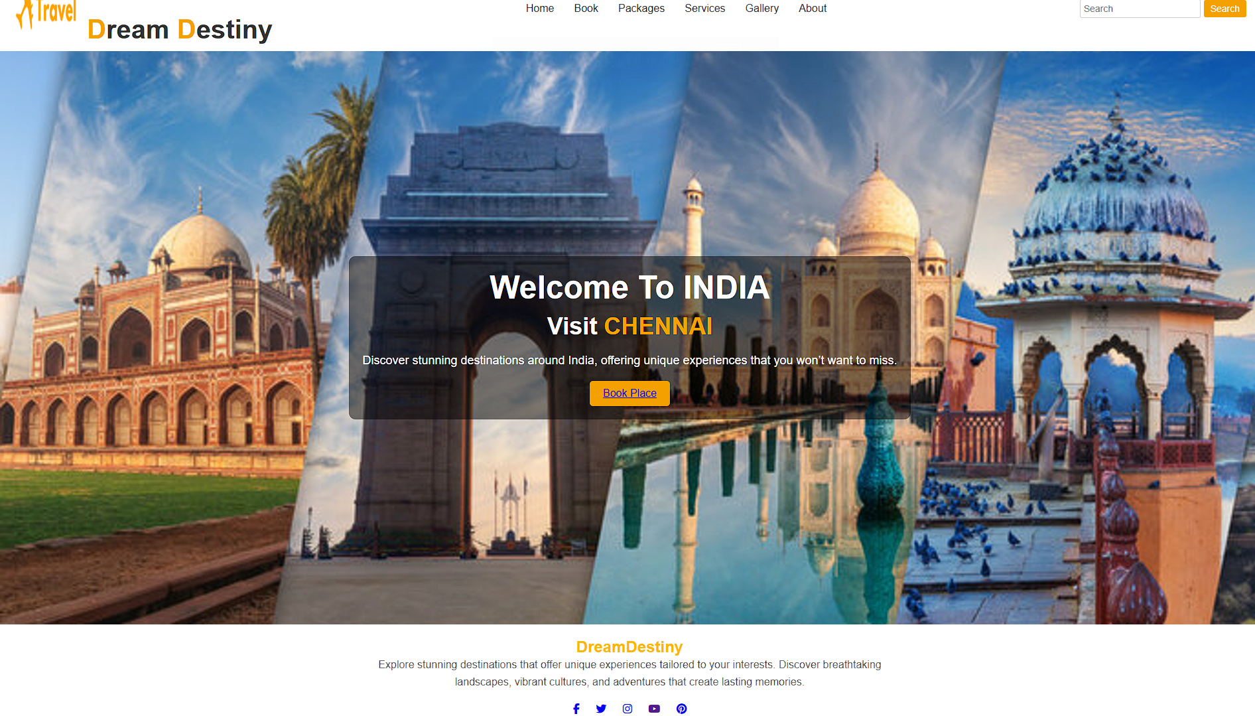

BOOKING PAGE

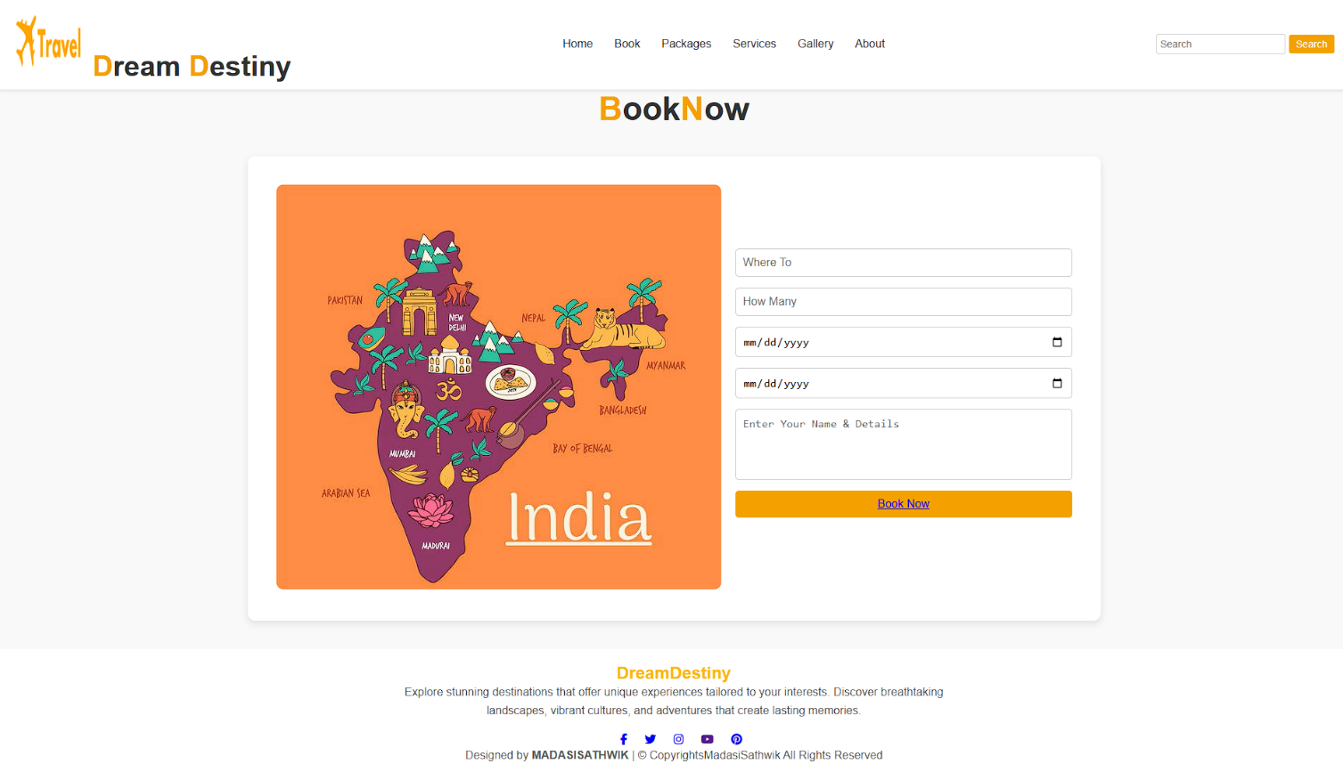

PACKAGES PAGE

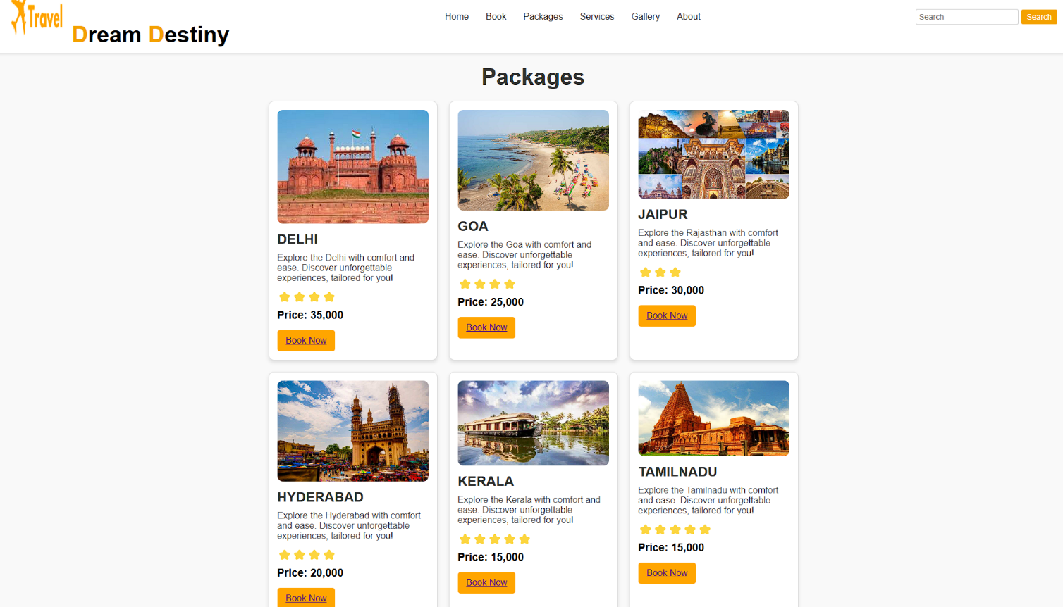

SERVICE PAGE

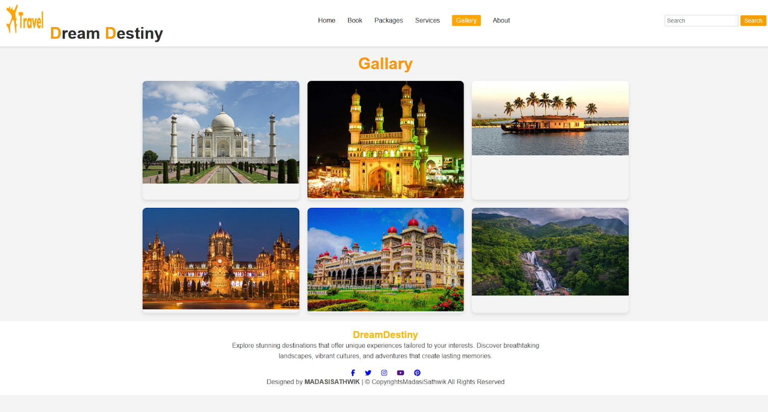

ABOUT US PAGE

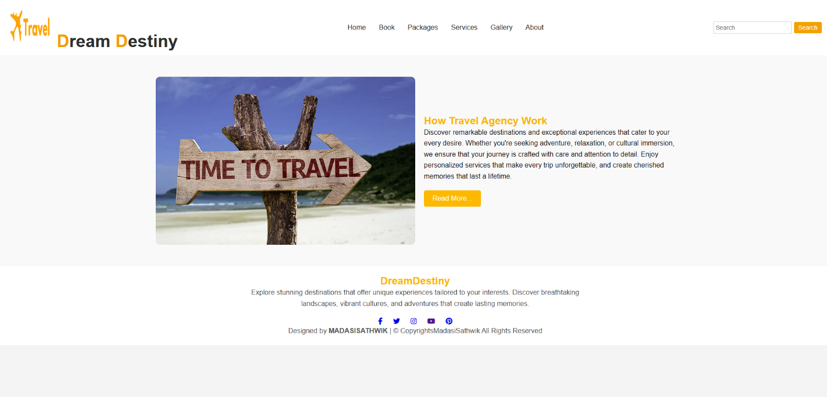

**CONCLUSION**

Finally, the Dream Destiny Travel Page hopes to reform trip preparation and travel for families and friends. Our goal is to help everyone by providing an affordable, convenient platform that is available even if money is tight. This one-stop-solution focus is what allows users to experience destinations with confidence, knowing their whole trip is fully catered for from accommodation and transport through to sightseeing and dining.

This desired initiative goes beyond a vehicle for journey; it is the creation of reminiscences. By providing affordable packages without compromising quality, we turn your dreams into reality. We provide customized itineraries, exclusive offers and round-the-clock customer support guaranteed seamless travel experience.

The Dream Destiny Travel Page aims to be a household name, connecting people and creating happiness by sharing travelling experiences. We ease the planning burden while providing trusted locations, so families and friends can focus on what truly matters: Time spent together making memories to last a lifetime. So travel the path of dreams, make journeys histories and let Dream Destiny Travel Page take you to your dream destination.